# **1.PASSPORT MANAGEMENT SYSTEM**

*USECASE DIAGRAM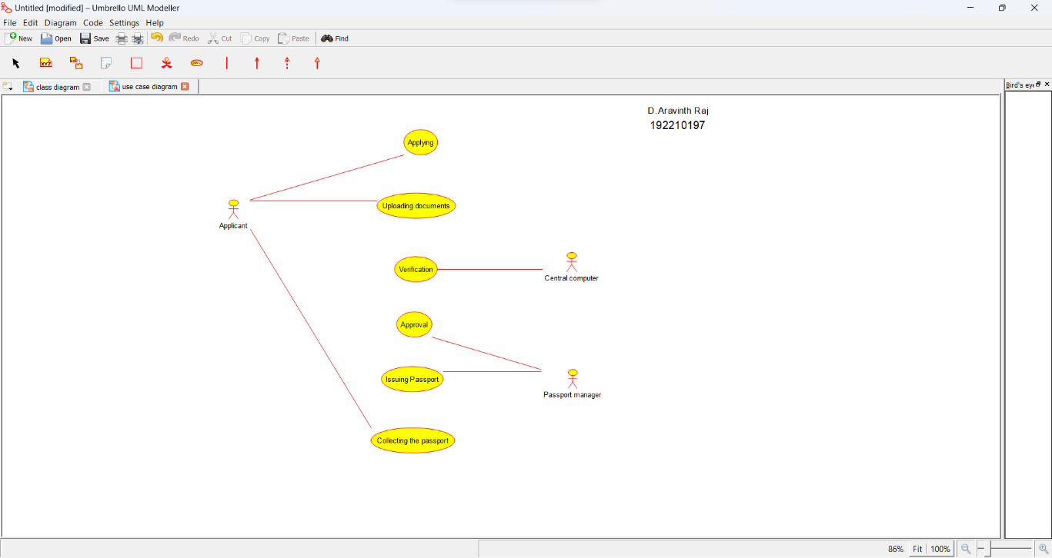*

*CLASS DIAGRAM*

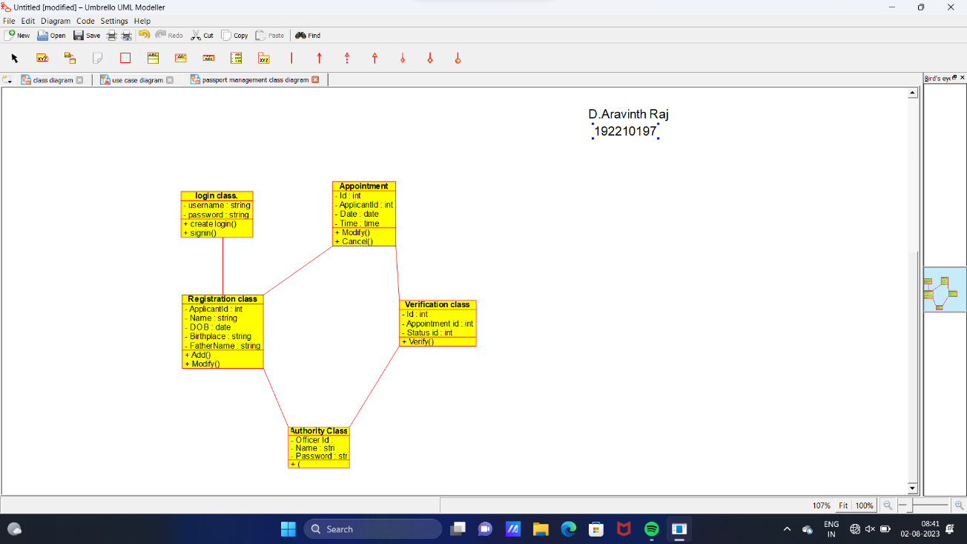

*ACTIVITY DIAGRAM*

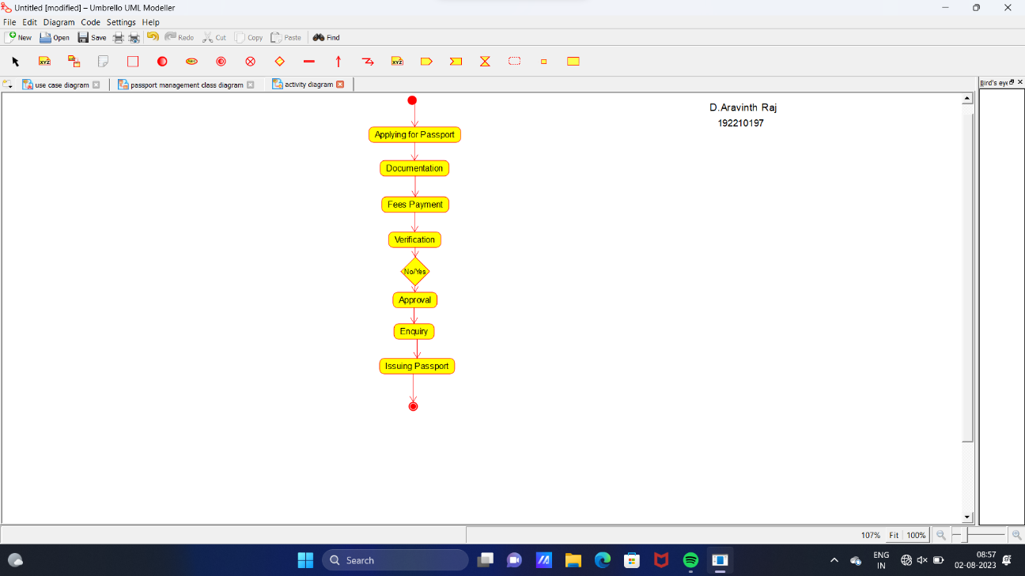

*SEQUENCE DIAGRAM*

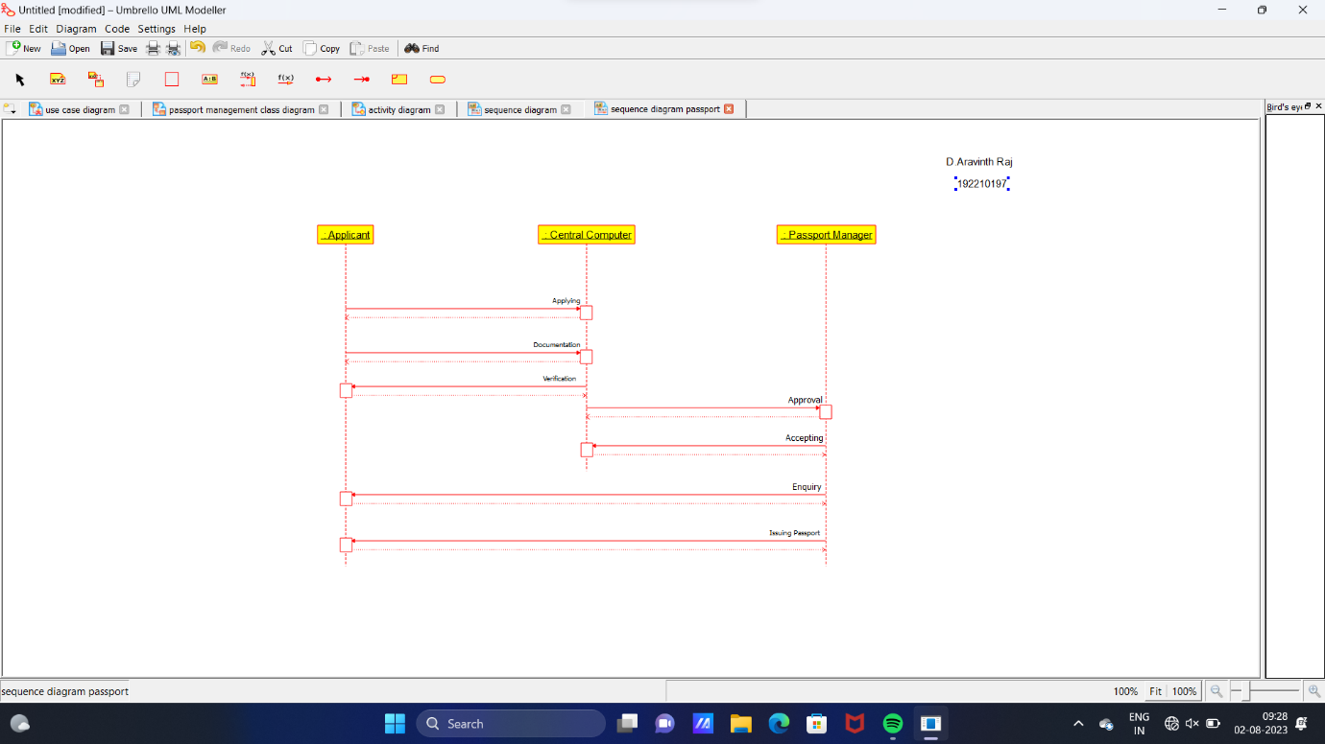

*STATE DIAGRAM*

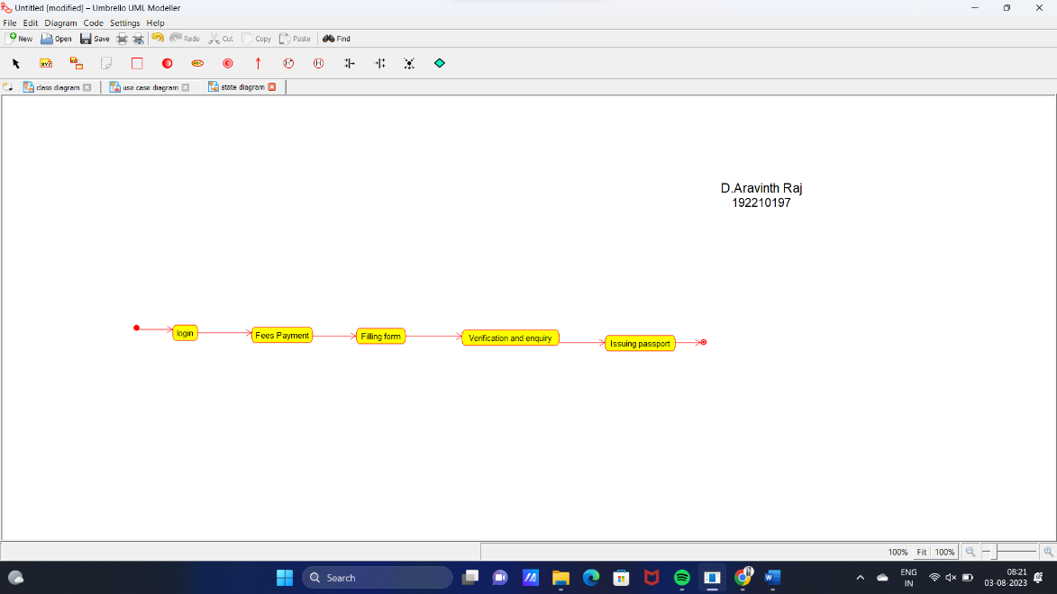

*COLLABRATION DIAGRAM*

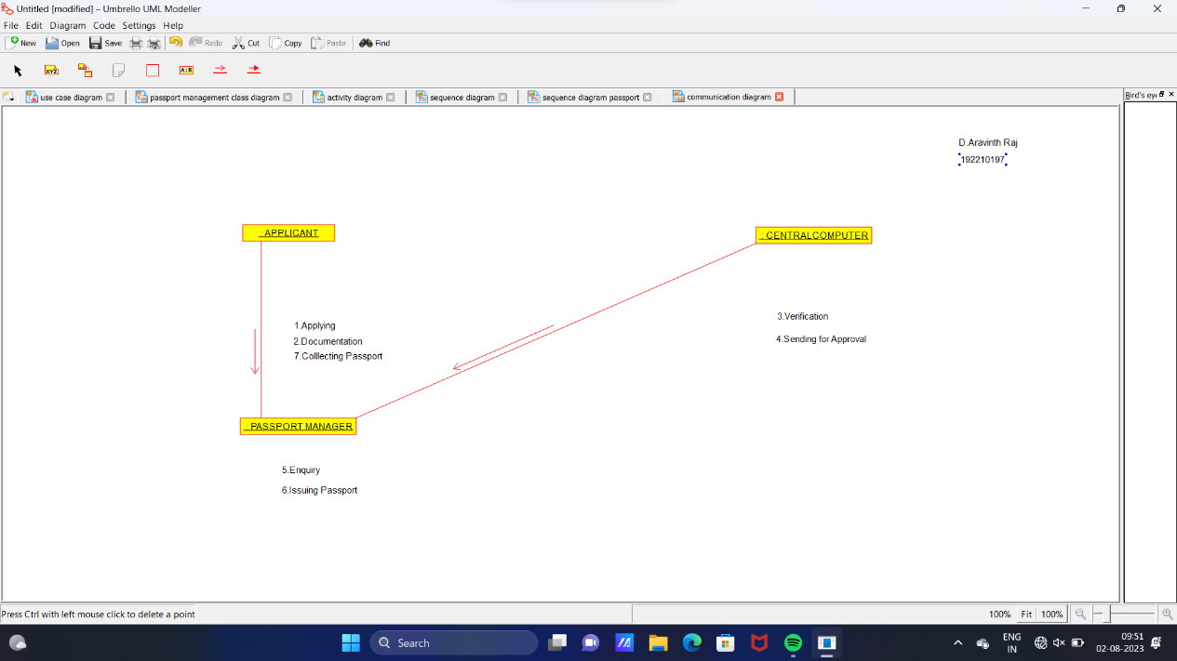

*COMPONENT DIAGRAM*

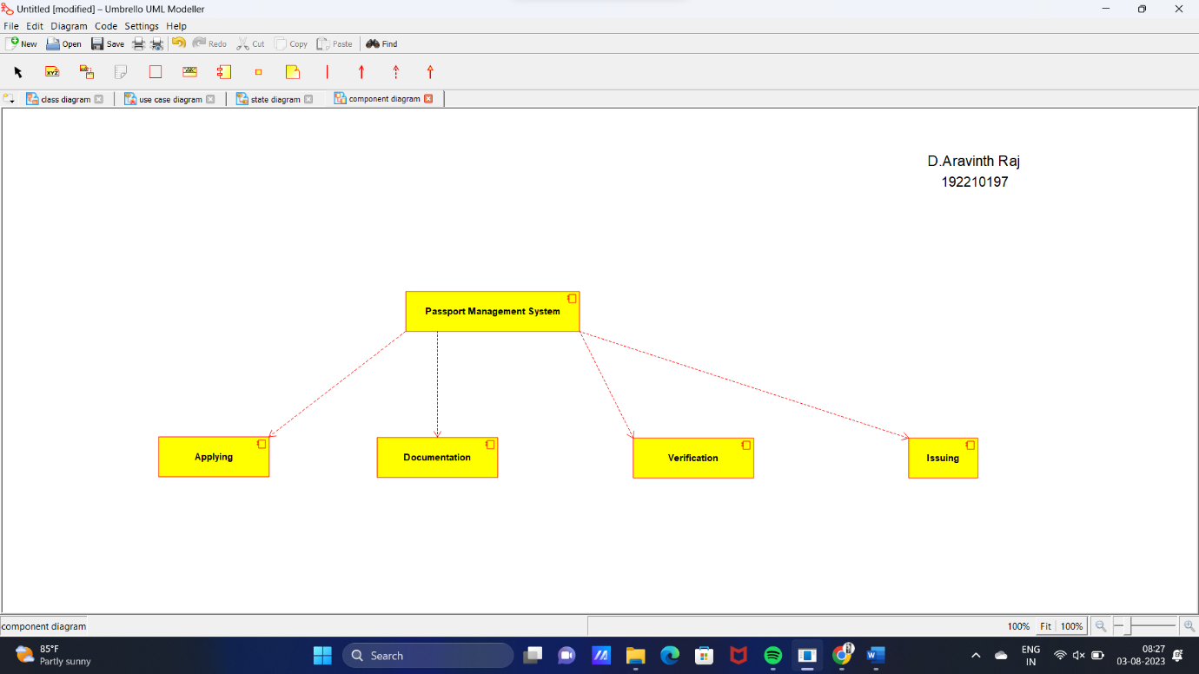

*DEPLOYMENT DIAGRAM*

